Usability Test- search function

Test plan:

1. System setup – test environment and equipment

Test environment includes Google Chrome, Mozilla Firefox within internet connection.

Equipment includes desktop, laptop, tablet and mobile device.

1. Starting point

home page

1. Who is the intended user

Intended user includes house buyer, real estate agent and website administrator.

1. URL of the system to be tested

<https://sfsuse.com/fa17g03/>

1. Task description

|  |  |
| --- | --- |
| TASK | DESCRIPTION |
| Task | Find listing property |
| Machine state | Empty search bar |
| Successful completion criteria | Corresponding property images appear in listing page |
| Benchmark | Completed in less than 1 second |

1. Completion criteria

User has successfully done the following:

* Founding all listing properties according to typed city name, zip code or address.

QA test – HW and SW set up

HW setup:

Equipment is a MacBook Pro laptop

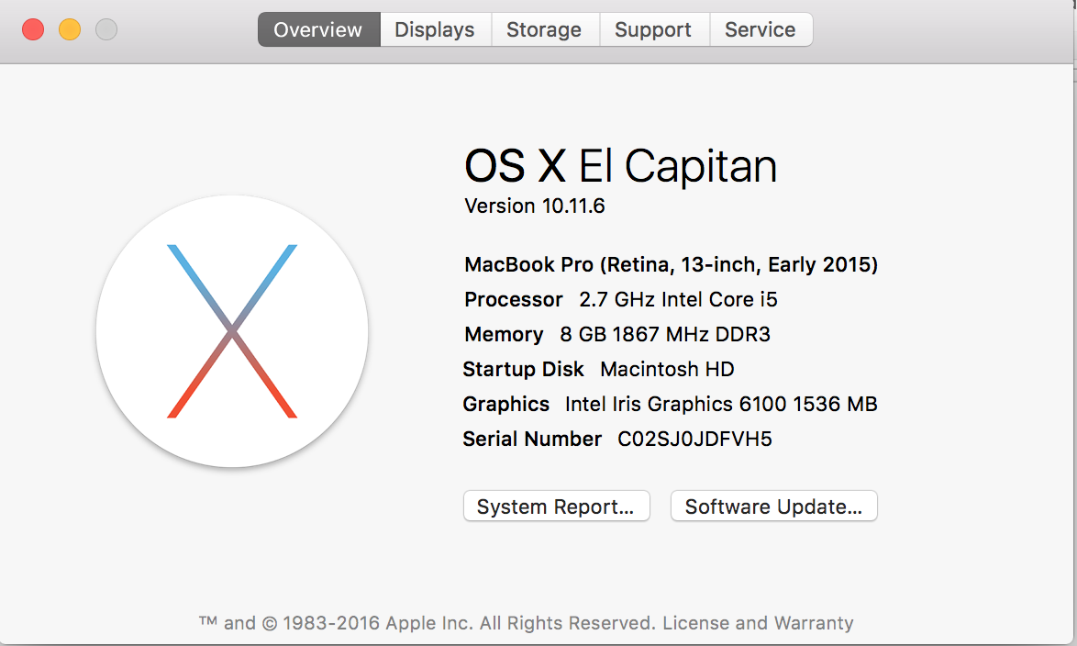

SW setup:

Google Chrome browser (version 61.0.3163.100) within home wifi connection.

URL of the system to be tested:

<https://sfsuse.com/fa17g03/>

QA test - test plan

|  |  |  |  |  |
| --- | --- | --- | --- | --- |
| Number of open bugs in time | Description | Test input | Expected output | Pass/Fail |
|  | Setup:  Open the following link in browser:  <https://www.sfsuse.com/fa17g03/>  description:  Users shall be able to search for property by using “Address” filter. | Category: address  Search box:  1600 Holloway, San Francisco, CA 94132  click button:  search | Search result returns with a detail listing page of “1600 Holloway, San Francisco, CA 94132” | Pass |
|  | Setup:  Open the following link in browser:  <https://www.sfsuse.com/fa17g03/>  description:  Users shall be able to search for property by using “City” filter. | Category:  City  Search box:  San Francisco  click button:  search | Search result returns with a listing page with all properties located in “San Francisco” | Pass |
|  | Setup:  Open the following link in browser:  <https://www.sfsuse.com/fa17g03/>  description:  Users shall be able to search for property by using “Zip code” filter. | Category:  Zip code  Search box:  94110  click button:  search | Search result returns with a listing page of all properties located in zip code “94110” | Pass |
|  | Setup:  Open the following link in browser:  <https://www.sfsuse.com/fa17g03/>  description:  Users shall be able to search for property by using “All” filter. | Category:  All  Search box:  210 Juniper St, San Diego, CA 94101  click button:  search | Search result returns with a detail listing page of property located in “210 Juniper St, San Diego, CA 94101” | Pass |

|  |  |  |  |  |
| --- | --- | --- | --- | --- |
| Number of open bugs in time | Description | Test input | Expected output | Pass/Fail |
| 0 | Setup:  Open the following link in browser:  <https://www.sfsuse.com/fa17g03/>  description:  Users shall be able to search for property by using “All” filter. | Category:  All  Search box:  San Diego  click button:  search | Search result returns with a listing page of all property located in “San Diego” | Pass |
| 0 | Setup:  Open the following link in browser:  <https://www.sfsuse.com/fa17g03/>  description:  Users shall be able to search for property by using “All” filter. | Category:  All  Search box:  94116  click button:  search | Search result returns with a listing page of all property located in “94116” | Pass |